**ЕГЭ английский язык (личное письмо другу)**

**Схема неформального письма**

Письмо к другу имеет следующий вид:

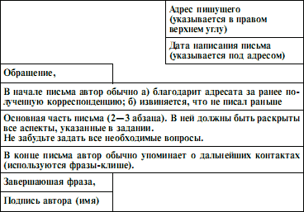

*Образец письма личного характера*

**Задание и образец выполнения:**

You have received a letter from your English-speaking pen friend Steve who writes

*…At school we are doing projects on reading habits of people in different countries. Could you tell me what kind of books you and the members of your family like reading?*

*As for the family news, my sister got married last week…*

Write a letter to Steve. In your letter

– tell him about the kinds of books you and your relatives like to read

– ask **3 questions** about his sister’s husband.

Write 100–140 words. Remember the rules of letter writing.

Samara

Russia

June 10th, 2017

Dear Steve,

Thanks a lot for your letter. Sorry, I haven’t answered at once. I was really busy with my study.

In your letter you asked me about reading habits in my family. Well, my father often reads newspapers and magazines. He thinks that it’s the only way to be in the know of everything and my mother’s keen on reading modern novels. However, she wouldn’t mind reading about lives of celebrities.

As for me, I enjoy reading detective stories because they have interesting story lines and unusual endings. I’m particularly captivated by characters who conduct investigations.

By the way, I’m glad your sister got married. What’s her husband’s name? Where’s he from? Is he a student?

Actually, I have to stop now as I’ve got loads of homework. Write soon!

All the best,

Ivan